PISHPEK
Corner of Iskakovskaya and Krasnoryadskaya streets
42.86912, 74.61896
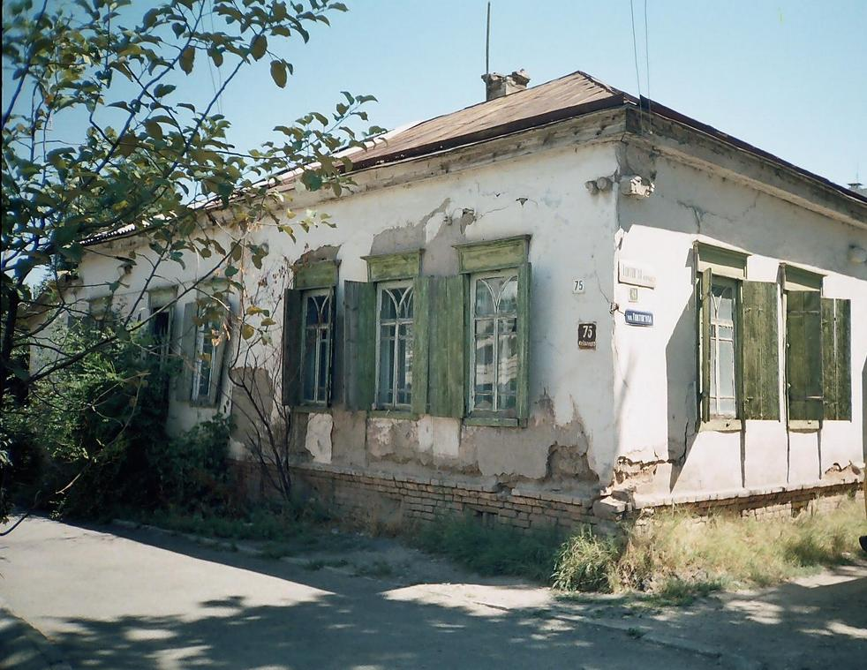
Угол улиц Искаковской и Краснорядской
ENGLISH Corner of Iskakovskaya and Krasnoryadskaya streets
﻿ North-eastern corner of Iskakovskaya and Krasnoryadskaya streets The construction of residential buildings in the city of Pishpek was carried out strictly according to plan. Rectilinear streets formed squares or rectangles of blocks and in one block there were four to six plots, each with an area of ​​0.1 hectares. Houses on courtyard estates were placed on the corner or in the center of the site, with the main facades facing the street. The ro
Source: https://bimap.su/description/pishpek/100_Severovostok_Krasnoriadskoi.txt · BIMAP
Фотографии и материалы принадлежат их авторам; лицензия не указана

FRUNZE
No information has been found for this period yet
42.86912, 74.61896

Фотография пока не добавлена
ENGLISH
No information has been found for this period yet.

BISHKEK
No information has been found for this period yet
42.86912, 74.61896

Фотография пока не добавлена
ENGLISH
No information has been found for this period yet.

