PISHPEK
Post office
42.88536, 74.61531
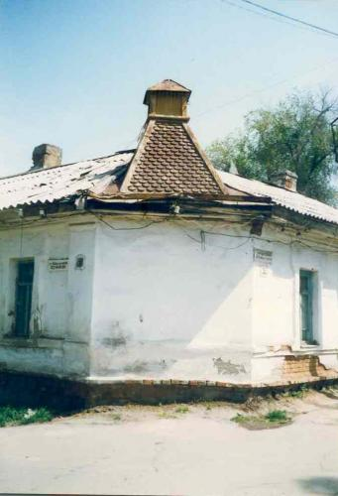
Почта · Владимира Петрова
ENGLISH Post office
﻿ Post office The first post office was built next to the horse-drawn postal station at the intersection of the main roads to Tashkent and Verny. Archival documents preserve the names of the first postal workers of Pishpek in 1873. They were telegraph operators Pyotr Metlev, Ivan Strozhe and watchman Egor Kudryavtsev. Later, the officials who managed the post office were among the leading people in the county.
Source: https://bimap.su/description/pishpek/10_Pochta.txt · BIMAP
Фотографии и материалы принадлежат их авторам; лицензия не указана

FRUNZE
No information has been found for this period yet
42.88536, 74.61531

Фотография пока не добавлена
ENGLISH
No information has been found for this period yet.

BISHKEK
No information has been found for this period yet
42.88536, 74.61531

Фотография пока не добавлена
ENGLISH
No information has been found for this period yet.

