PISHPEK
No information has been found for this period yet
42.83311, 74.61066

Фотография пока не добавлена
ENGLISH
No information has been found for this period yet.

FRUNZE
School No. 64 in the 8th microdistrict
42.83311, 74.61066
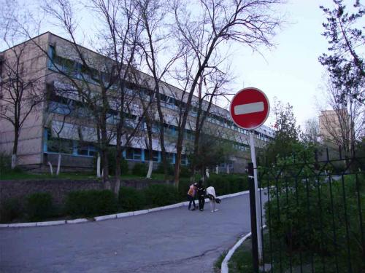
Школа №64 в 8-м микрорайоне
ENGLISH School No. 64 in the 8th microdistrict
﻿ School No. 64 in the 8th microdistrict In the 80s, more than 80 secondary schools functioned in the city of Frunze. Anastasia Petrova graduated from this school.
Source: https://bimap.su/description/frunze/384_Shkola64.txt · BIMAP
Фотографии и материалы принадлежат их авторам; лицензия не указана

BISHKEK
No information has been found for this period yet
42.83311, 74.61066

Фотография пока не добавлена
ENGLISH
No information has been found for this period yet.

