PISHPEK
No information has been found for this period yet
42.84596, 74.59892

Фотография пока не добавлена
ENGLISH
No information has been found for this period yet.

FRUNZE
School No. 61
42.84596, 74.59892
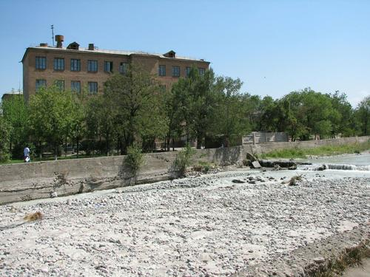
Школа №61
ENGLISH School No. 61
﻿ School No. 61 School No. 61 was founded in 1963. Since 1966, it has positioned itself as an educational institution with in-depth study of mathematics and physics. In 1991, the school received the status of a physics and mathematics lyceum. And the next year it becomes the author’s school of Efim Yakir.
Source: https://bimap.su/description/frunze/451_Shkola61.txt · BIMAP
Фотографии и материалы принадлежат их авторам; лицензия не указана

BISHKEK
No information has been found for this period yet
42.84596, 74.59892

Фотография пока не добавлена
ENGLISH
No information has been found for this period yet.

