PISHPEK
No information has been found for this period yet
42.87655, 74.60396

Фотография пока не добавлена
ENGLISH
No information has been found for this period yet.

FRUNZE
A piece of Frunze. Photo from the 60s.
42.87655, 74.60396
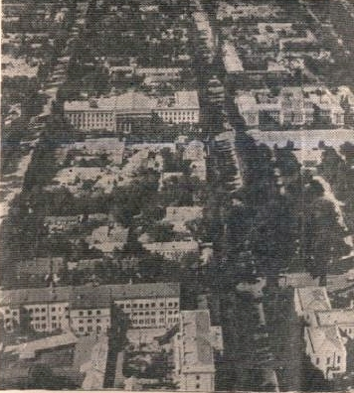
Кусочек Фрунзе. Фото 60-х. · 60-х
ENGLISH A piece of Frunze. Photo from the 60s.
﻿ A piece of Frunze. Photo of the 60s Kirgizskaya (Orozbekova) and Pervomaiskaya (Razzakova) streets. In the foreground on the left are the buildings of the KGB and the Ministry of Internal Affairs, on the right is the Academy of Sciences (Assembly of the People of Kyrgyzstan), in the center of the photo are the buildings of the Supreme Council and the Central Committee of the Party.
Source: https://bimap.su/description/frunze/405_KGB.txt · BIMAP
Фотографии и материалы принадлежат их авторам; лицензия не указана

BISHKEK
No information has been found for this period yet
42.87655, 74.60396

Фотография пока не добавлена
ENGLISH
No information has been found for this period yet.

