PISHPEK
No information has been found for this period yet
42.86897, 74.60528

Фотография пока не добавлена
ENGLISH
No information has been found for this period yet.

FRUNZE
School No. 6
42.86897, 74.60528
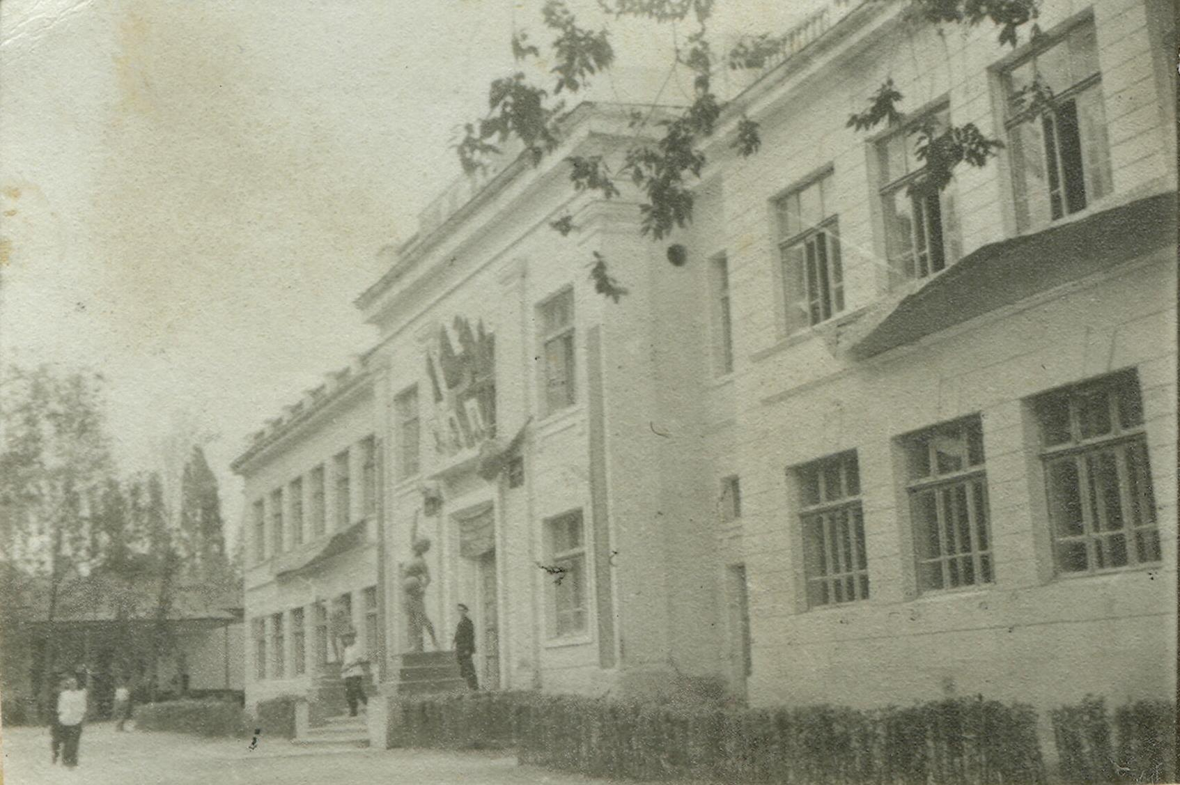
Школа №6
ENGLISH School No. 6
﻿ School No. 6 on Pionerskaya Street (Moskovskaya) By 1940, there were 34 schools in the city education network. School No. 6 was opened in 1936. During the war, it began to bear the name of Hero of the Soviet Union, General I.V. Panfilov. Photo from the newspaper “Soviet Kyrgyzstan” dated May 14, 1937. This sculpture of a woman with a ball stood at the entrance to the school. 7a grade of men's secondary school No. 6. Photo from 1951.
Source: https://bimap.su/description/frunze/196_Shkola6.txt · BIMAP
Фотографии и материалы принадлежат их авторам; лицензия не указана

BISHKEK
No information has been found for this period yet
42.86897, 74.60528

Фотография пока не добавлена
ENGLISH
No information has been found for this period yet.

