PISHPEK
No information has been found for this period yet
42.87435, 74.62158

Фотография пока не добавлена
ENGLISH
No information has been found for this period yet.

FRUNZE
No information has been found for this period yet
42.87435, 74.62158

Фотография пока не добавлена
ENGLISH
No information has been found for this period yet.

BISHKEK
Microdistrict Vostok-6
42.87435, 74.62158
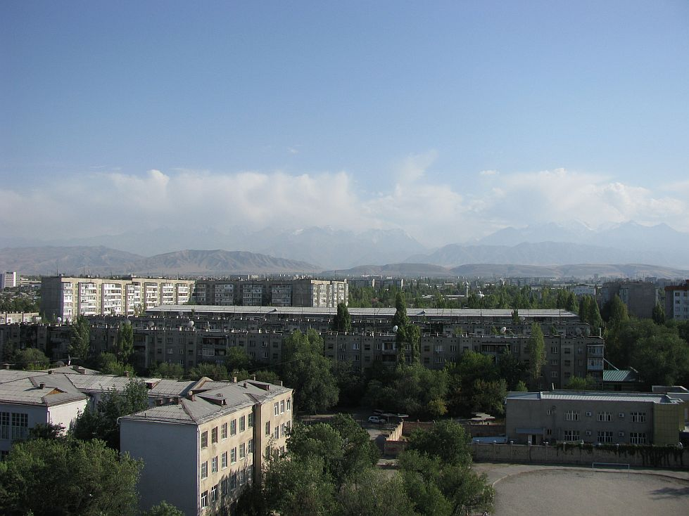
Микрорайон Восток-6 · Евгения Коровина
ENGLISH Microdistrict Vostok-6
Microdistrict Vostok-6. In the foreground is school No. 12. Photo by Evgeny Korovin.
Source: https://bimap.su/description/bishkek/31_IMG_0505.txt · BIMAP
Фотографии и материалы принадлежат их авторам; лицензия не указана

