PISHPEK
No information has been found for this period yet
42.88530, 74.62555

Фотография пока не добавлена
ENGLISH
No information has been found for this period yet.

FRUNZE
High-rise buildings on the street 50 years of the Kirghiz SSR
42.88530, 74.62555
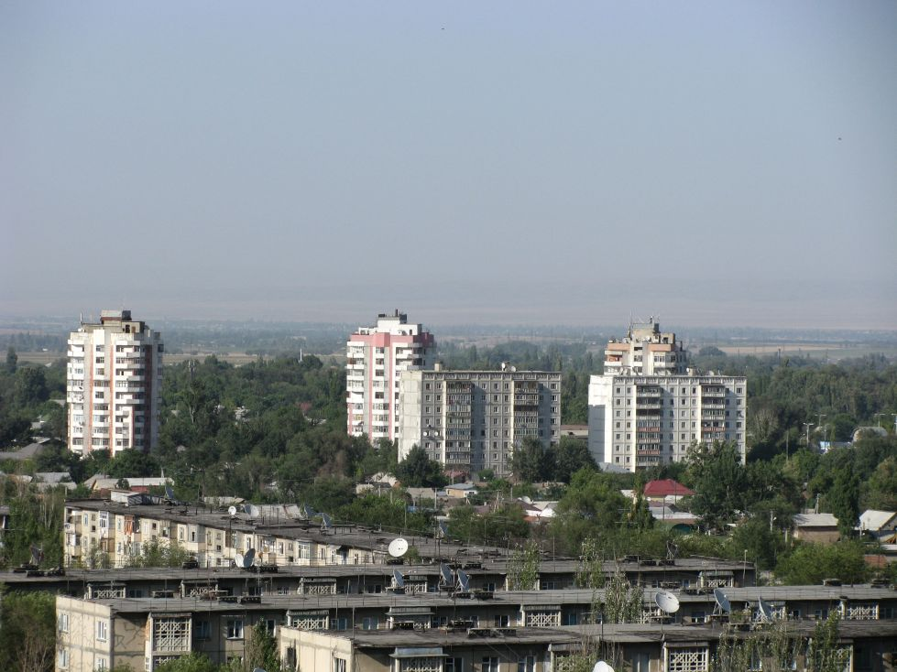
Высотки на улице 50 лет Киргизской ССР · Евгения Коровина
ENGLISH High-rise buildings on the street 50 years of the Kirghiz SSR
﻿ High-rise buildings for 50 years of the Kirghiz SSR (Zhibek Zholu) High-rise buildings for 50 years of the Kirghiz SSR (Zhibek Zholu). Photo by Evgeny Korovin.
Source: https://bimap.su/description/frunze/500_Vysotki.txt · BIMAP
Фотографии и материалы принадлежат их авторам; лицензия не указана

BISHKEK
No information has been found for this period yet
42.88530, 74.62555

Фотография пока не добавлена
ENGLISH
No information has been found for this period yet.

