PISHPEK
No information has been found for this period yet
42.87256, 74.61105

Фотография пока не добавлена
ENGLISH
No information has been found for this period yet.

FRUNZE
School No. 5
42.87256, 74.61105
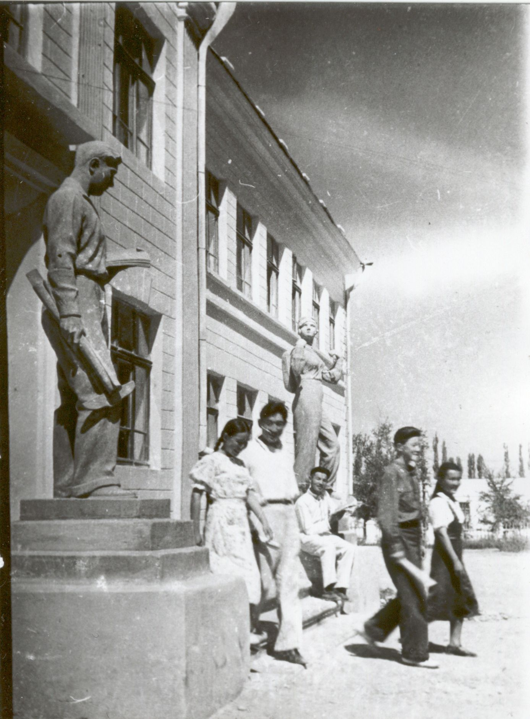
Школа №5
ENGLISH School No. 5
﻿ Kyrgyz school No. 5 named after. A.S. Pushkin By 1940, there were 34 schools in the city education network. Kyrgyz school No. 5 named after. A.S. Pushkin was organized in 1926. as primary, in 1932 she becomes seven years old, and from 1936 - ten years old in this building. The first graduation of 17 people took place in 1939. In the early 70s, the publishing houses "Kyrgyzstan", "Mektep" were located in the school building; in 1988, "Adabiyat",
Source: https://bimap.su/description/frunze/197_Shkola5.txt · BIMAP
Фотографии и материалы принадлежат их авторам; лицензия не указана

BISHKEK
No information has been found for this period yet
42.87256, 74.61105

Фотография пока не добавлена
ENGLISH
No information has been found for this period yet.

