PISHPEK
No information has been found for this period yet
42.86232, 74.54518

Фотография пока не добавлена
ENGLISH
No information has been found for this period yet.

FRUNZE
School No. 44
42.86232, 74.54518
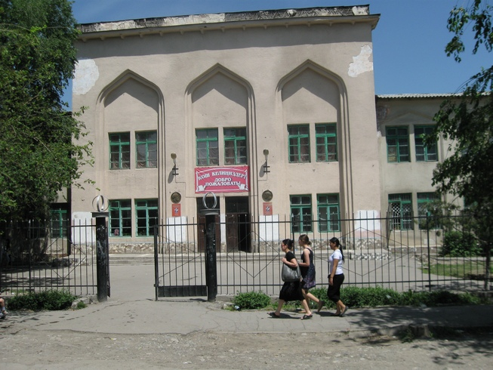
Школа №44 · Владимира Петрова
ENGLISH School No. 44
﻿ School No. 44. Photo by Petrov School No. 44.
Source: https://bimap.su/description/frunze/29_Shkola44.txt · BIMAP
Фотографии и материалы принадлежат их авторам; лицензия не указана

BISHKEK
No information has been found for this period yet
42.86232, 74.54518

Фотография пока не добавлена
ENGLISH
No information has been found for this period yet.

