PISHPEK
No information has been found for this period yet
42.87688, 74.59993

Фотография пока не добавлена
ENGLISH
No information has been found for this period yet.

FRUNZE
City Stadium, 30th
42.87688, 74.59993
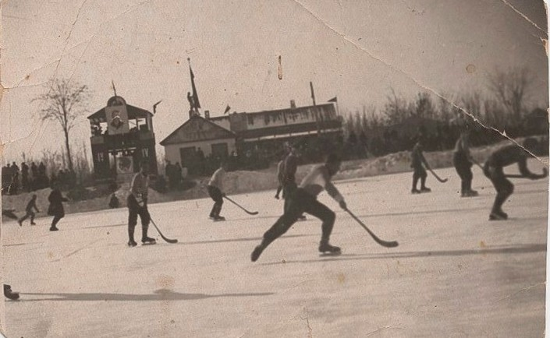
Городской стадион, 30-е
ENGLISH City Stadium, 30th
﻿ City Stadium, 30th. Photo from the collection of V. Petrov The city stadium was built by youth in 1932. At one time it bore the name of the sports society “Labor Reserves”. The stadium hosted military sports games, football matches, and hockey tournaments. The skating rink on the football field of the stadium was flooded every winter. In 1989, the Government House was built on the site of the stadium.
Source: https://bimap.su/description/frunze/84_Stadion30.txt · BIMAP
Фотографии и материалы принадлежат их авторам; лицензия не указана

BISHKEK
No information has been found for this period yet
42.87688, 74.59993

Фотография пока не добавлена
ENGLISH
No information has been found for this period yet.

