ТОГДА / СЕЙЧАС
Школа №3
42.87905, 74.60632
Тогда · Frunze
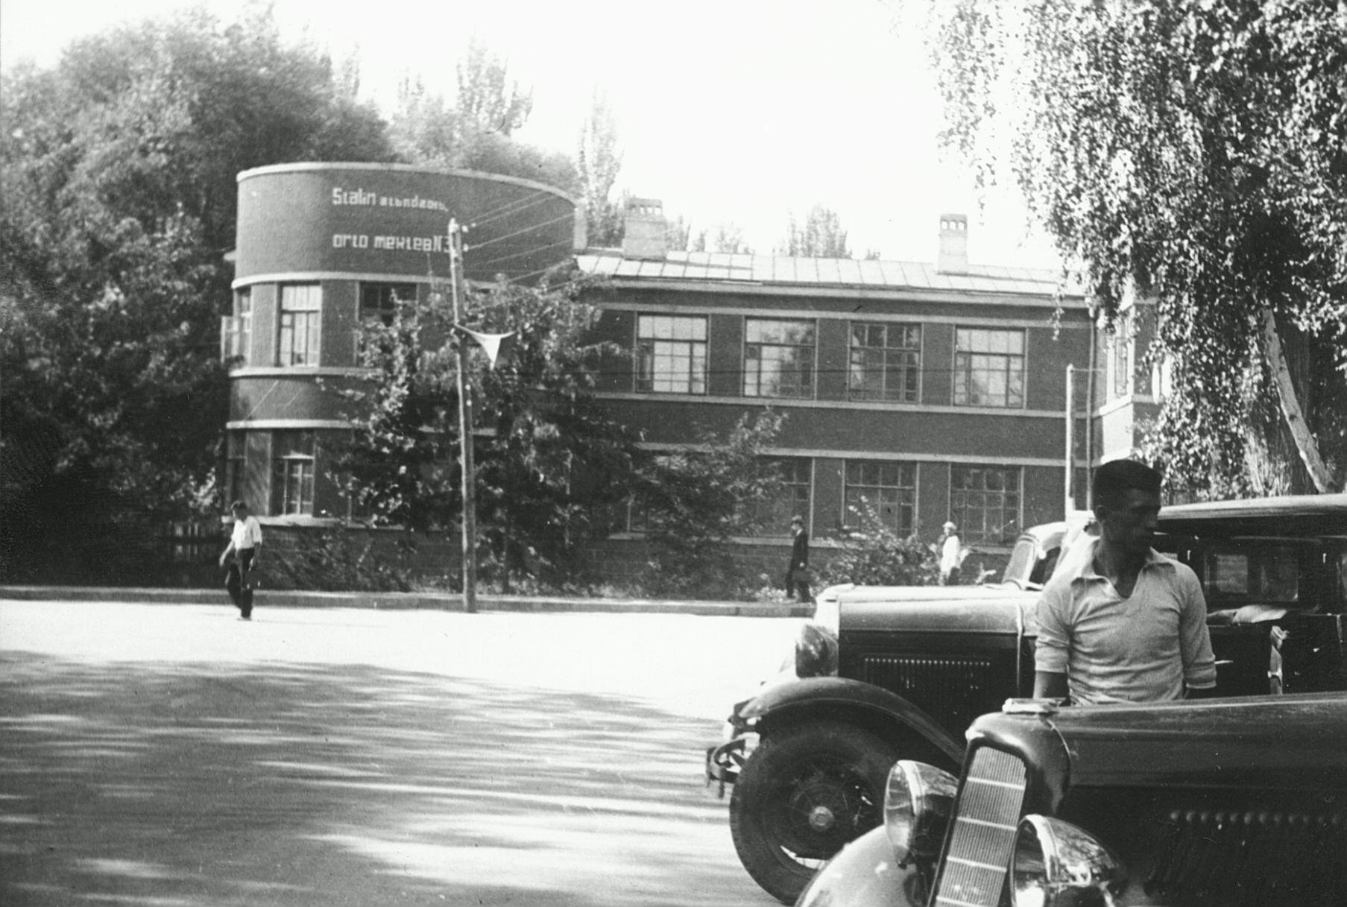
Сейчас · Bishkek


PISHPEK
No information has been found for this period yet
42.87905, 74.60632

Фотография пока не добавлена
ENGLISH
No information has been found for this period yet.

FRUNZE
School No. 3
42.87905, 74.60632
Школа №3 · 30-х годов
ENGLISH School No. 3
﻿ School No. 3 named after Stalin, photo from the 30s By 1940, there were 34 schools in the city education network. School No. 3 named after Stalin was built in 1934 according to the design of the architect A.T.Madyud. After 1968, this building housed the children's library named after. Frunze.
Source: https://bimap.su/description/frunze/195_Shkola3.txt · BIMAP
Фотографии и материалы принадлежат их авторам; лицензия не указана

BISHKEK
No information has been found for this period yet
42.87905, 74.60632
Современный вид; дата публикации в 2GIS · Юрий Крюков
ENGLISH
No information has been found for this period yet.
Source: https://2gis.kg/bishkek/geo/15763234351122893/tab/photos · 2GIS
Фотография пользователя 2GIS; права принадлежат автору. Изображение показывается по внешней ссылке на 2GIS.

