PISHPEK
No information has been found for this period yet
42.86779, 74.60078

Фотография пока не добавлена
ENGLISH
No information has been found for this period yet.

FRUNZE
School No. 28
42.86779, 74.60078
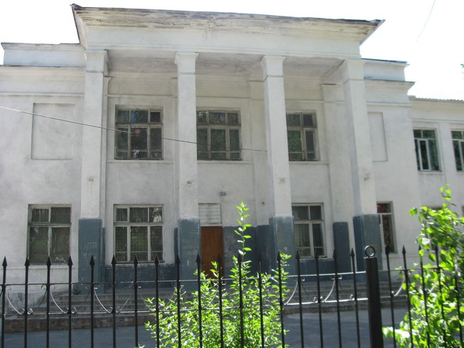
Школа №28
ENGLISH School No. 28
﻿ School No. 28 By 1940, there were 34 schools in the city's educational network. School No. 28 named after Academician Scriabin. Built in the 30s. During the war, the building housed the fortification and construction department and a dormitory for students of the Military Engineering Academy named after. V.G.Kuibysheva.
Source: https://bimap.su/description/frunze/198_Shkola28.txt · BIMAP
Фотографии и материалы принадлежат их авторам; лицензия не указана

BISHKEK
No information has been found for this period yet
42.86779, 74.60078

Фотография пока не добавлена
ENGLISH
No information has been found for this period yet.

