PISHPEK
No information has been found for this period yet
42.87390, 74.60864

Фотография пока не добавлена
ENGLISH
No information has been found for this period yet.

FRUNZE
School No. 24
42.87390, 74.60864
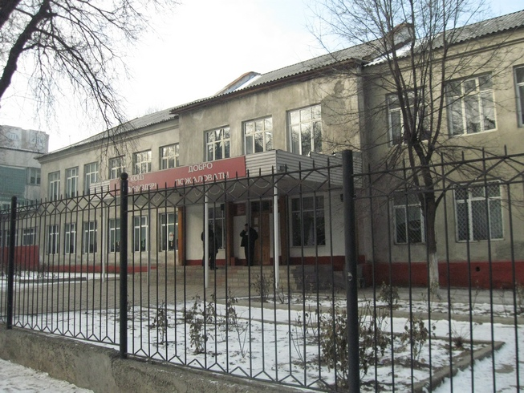
Школа №24 · Владимира Петрова
ENGLISH School No. 24
﻿ School No. 24 By 1940, there were 34 schools in the city's educational network. School No. 24 was originally Uzbek named after Alisher Navoi. In 1941, it housed the headquarters of the 40th Pomeranian Separate Rifle Brigade. Hero of the Soviet Union Talgat Begeldinov studied at this school twice. Vladimir Petrov graduated from this school in 1958.
Source: https://bimap.su/description/frunze/193_Shkola24.txt · BIMAP
Фотографии и материалы принадлежат их авторам; лицензия не указана

BISHKEK
No information has been found for this period yet
42.87390, 74.60864

Фотография пока не добавлена
ENGLISH
No information has been found for this period yet.

