PISHPEK
No information has been found for this period yet
42.87158, 74.57231

Фотография пока не добавлена
ENGLISH
No information has been found for this period yet.

FRUNZE
Maternity hospital No. 2
42.87158, 74.57231
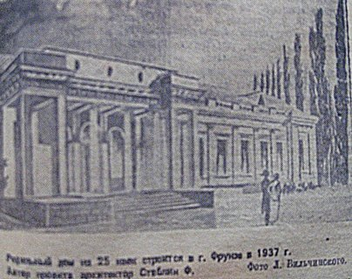
Родильный дом №2
ENGLISH Maternity hospital No. 2
Maternity hospital No. 2, architect F. Steblin, 1937 Maternity hospital No. 2, architect F. Steblin, 1937 Today, fragments of this house can be seen in the courtyard of the new maternity hospital building. Photo by Evgeny Petrov. As well as a relic of the mother’s sculpture. Photo by Evgeny Petrov.
Source: https://bimap.su/description/frunze/465_Roddom2.txt · BIMAP
Фотографии и материалы принадлежат их авторам; лицензия не указана

BISHKEK
No information has been found for this period yet
42.87158, 74.57231

Фотография пока не добавлена
ENGLISH
No information has been found for this period yet.

