ТОГДА / СЕЙЧАС
Цех №2 швейной фабрики «1 Мая»
42.88564, 74.62022
Тогда · Pishpek
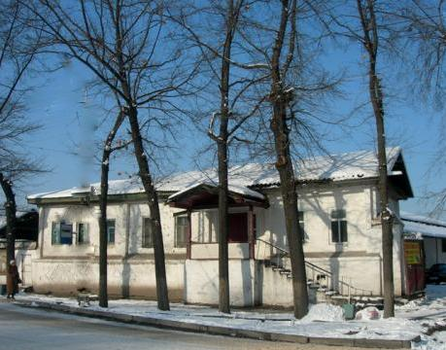
Сейчас · Bishkek


PISHPEK
Northern side of Tashkentskaya street
42.88564, 74.62022
Северная сторона улицы Ташкентской · Виктора Глумскова
ENGLISH Northern side of Tashkentskaya street
﻿ Northern side of Tashkentskaya The end of the 19th - beginning of the 20th centuries is characterized by the improvement of the city and the construction of large houses at the head of the city estate. The houses stood on high stone foundations made of cobblestones or ashlars, above which there was a brick basement with a patterned decor of the brickwork. The walls of the upper floors are frame-wooden or log. The number of rooms was determined
Source: https://bimap.su/description/pishpek/88_Sever_Tashkentskoi.txt · BIMAP
Фотографии и материалы принадлежат их авторам; лицензия не указана

FRUNZE
Workshop No. 2 of the 1st May garment factory
42.88564, 74.62022
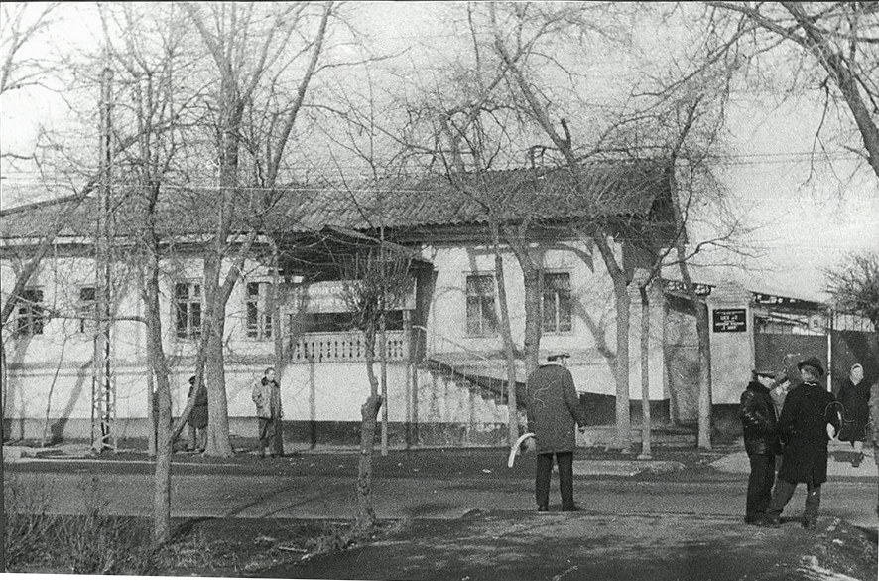
Цех №2 швейной фабрики «1 Мая»
ENGLISH Workshop No. 2 of the 1st May garment factory
﻿ Workshop No. 2 of the 1st May garment factory House built at the end of the 19th – beginning of the 20th centuries. The house, significant in size, stood at the head of the city estate on a high stone foundation, above which there was a brick basement of the semi-basement with patterned decor of the brickwork. The walls of the upper floor are framed wood or logs. The number of rooms was determined by the wealth of the city dweller, but more oft
Source: https://bimap.su/description/frunze/261_Zeh.txt · BIMAP
Фотографии и материалы принадлежат их авторам; лицензия не указана

BISHKEK
No information has been found for this period yet
42.88564, 74.62022
Современный вид; дата публикации в 2GIS · Айгул Жумашалиева
ENGLISH
No information has been found for this period yet.
Source: https://2gis.kg/bishkek/geo/15763234351122559/tab/photos · 2GIS
Фотография пользователя 2GIS; права принадлежат автору. Изображение показывается по внешней ссылке на 2GIS.

