PISHPEK
No information has been found for this period yet
42.83304, 74.60767

Фотография пока не добавлена
ENGLISH
No information has been found for this period yet.

FRUNZE
Sovetskaya street. Photo from 1979
42.83304, 74.60767
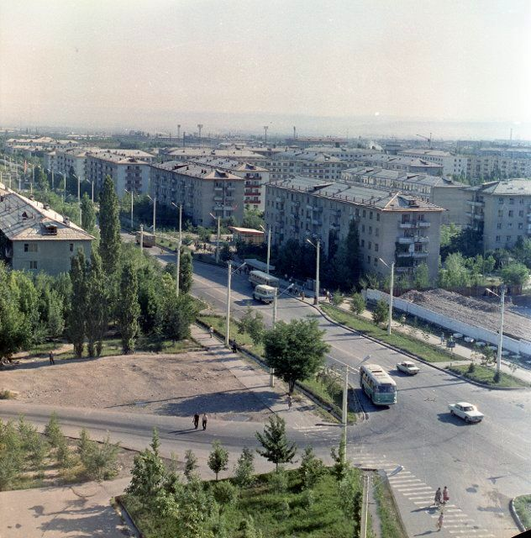
Улица Советская. Фото 1979 года · 1979 года
ENGLISH Sovetskaya street. Photo from 1979
﻿ Sovetskaya Street Sovetskaya Street, separating the 8th and 9th microdistricts. Photo from 1979. Sovetskaya Street is one of the main thoroughfares of the city, connecting its old and new parts and passing through the entire city from south to north.
Source: https://bimap.su/description/frunze/399_Sov8_9.txt · BIMAP
Фотографии и материалы принадлежат их авторам; лицензия не указана

BISHKEK
No information has been found for this period yet
42.83304, 74.60767

Фотография пока не добавлена
ENGLISH
No information has been found for this period yet.

