PISHPEK
No information has been found for this period yet
42.87854, 74.59982

Фотография пока не добавлена
ENGLISH
No information has been found for this period yet.

FRUNZE
Summer Theatre, 1965
42.87854, 74.59982
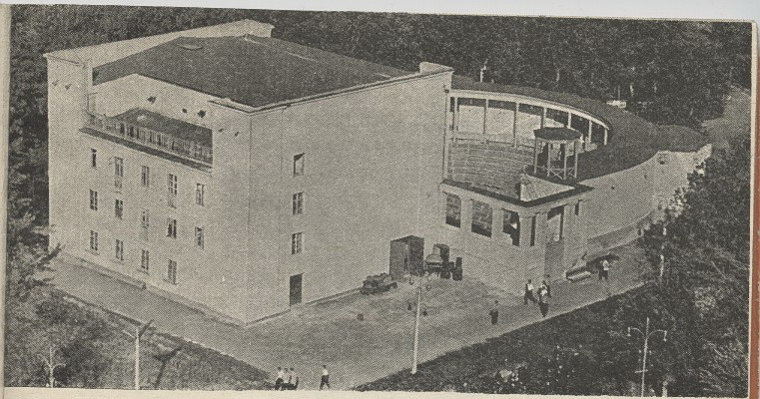
Летний театр, 1965г.
ENGLISH Summer Theatre, 1965
﻿ Summer theater. 1965 Summer theater with 800 seats. Architect G.A. Gradov, 1940. Classical and national elements were used in the architecture of this building. Here on August 13, 1943, a ceremonial meeting was held regarding the creation of the Kyrgyz branch of the Academy of Sciences with the participation of V.L. Komarov-President of the USSR Academy of Sciences. During the war years, an orchestra led by Isaac Dunaevsky, the Leningrad Gypsy
Source: https://bimap.su/description/frunze/141_Letnii_teatr.txt · BIMAP
Фотографии и материалы принадлежат их авторам; лицензия не указана

BISHKEK
No information has been found for this period yet
42.87854, 74.59982

Фотография пока не добавлена
ENGLISH
No information has been found for this period yet.

