PISHPEK
No information has been found for this period yet
42.85882, 74.61074

Фотография пока не добавлена
ENGLISH
No information has been found for this period yet.

FRUNZE
Sovetskaya street. Photo from 1962.
42.85882, 74.61074
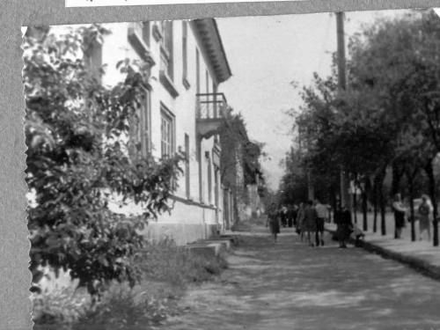
Улица Советская. Фото 1962 года. · 1962 года
ENGLISH Sovetskaya street. Photo from 1962.
﻿ Sovetskaya Street Sovetskaya Street. The first two-story houses of the Kamensk expedition. Photo from 1962.
Source: https://bimap.su/description/frunze/385_Novosov1962.txt · BIMAP
Фотографии и материалы принадлежат их авторам; лицензия не указана

BISHKEK
No information has been found for this period yet
42.85882, 74.61074

Фотография пока не добавлена
ENGLISH
No information has been found for this period yet.

