ТОГДА / СЕЙЧАС
Дом на Садовой
42.86818, 74.60012
Тогда · Pishpek
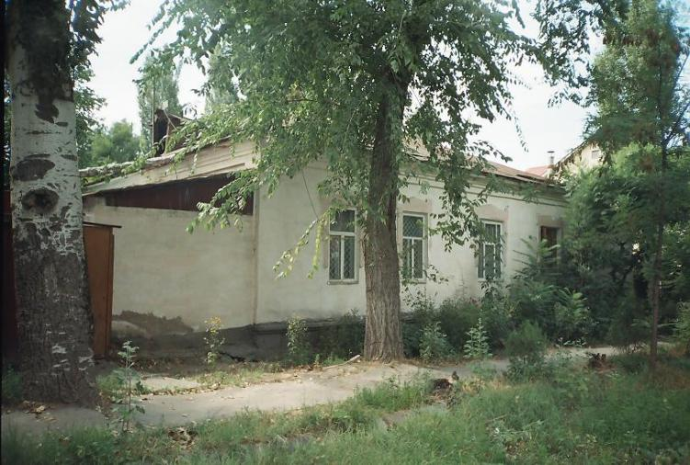
Сейчас · Bishkek


PISHPEK
House built in 1916
42.86818, 74.60012
Дом постройки 1916 года · Владимира Петрова
ENGLISH House built in 1916
﻿ Southwestern corner of Sadovaya and Lagernaya. The house was built in 1916. The end of the 19th and beginning of the 20th centuries was characterized by the improvement of the city and the construction of large houses at the head of the city estate. The houses stood on high stone foundations made of cobblestones or ashlars, above which there was a brick basement of the semi-basement or first floor with patterned decor of the brickwork. The wall
Source: https://bimap.su/description/pishpek/109_Ugozapad_Sadovoi.txt · BIMAP
Фотографии и материалы принадлежат их авторам; лицензия не указана

FRUNZE
House on Sadovaya
42.86818, 74.60012
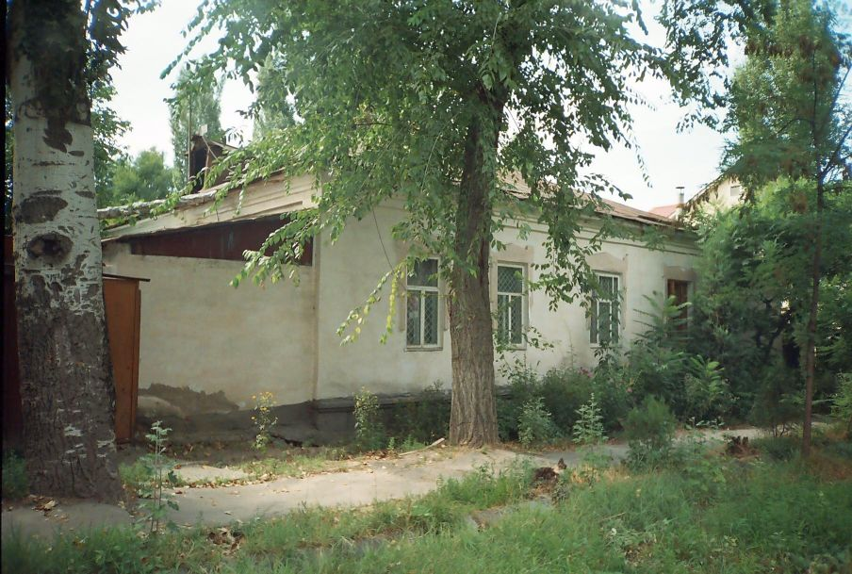
Дом на Садовой · Владимира Петрова
ENGLISH House on Sadovaya
﻿ House on Sadovaya built in 1916 The beginning of the twentieth century is characterized by the improvement of the city and the construction of large houses at the head of the city estate. The houses stood on high stone foundations made of cobblestones, above which there was a brick basement with a patterned decor of the brickwork. The walls are brick, but could also be adobe. The number of rooms was determined by the wealth of the city dweller,
Source: https://bimap.su/description/frunze/467_Dom_naSadovoi.txt · BIMAP
Фотографии и материалы принадлежат их авторам; лицензия не указана

BISHKEK
No information has been found for this period yet
42.86818, 74.60012
Современный вид; дата публикации в 2GIS · Svetlana S
ENGLISH
No information has been found for this period yet.
Source: https://2gis.kg/bishkek/geo/15763234351150417/tab/photos · 2GIS
Фотография пользователя 2GIS; права принадлежат автору. Изображение показывается по внешней ссылке на 2GIS.

