PISHPEK
No information has been found for this period yet
42.83510, 74.61366

Фотография пока не добавлена
ENGLISH
No information has been found for this period yet.

FRUNZE
16-storey building
42.83510, 74.61366
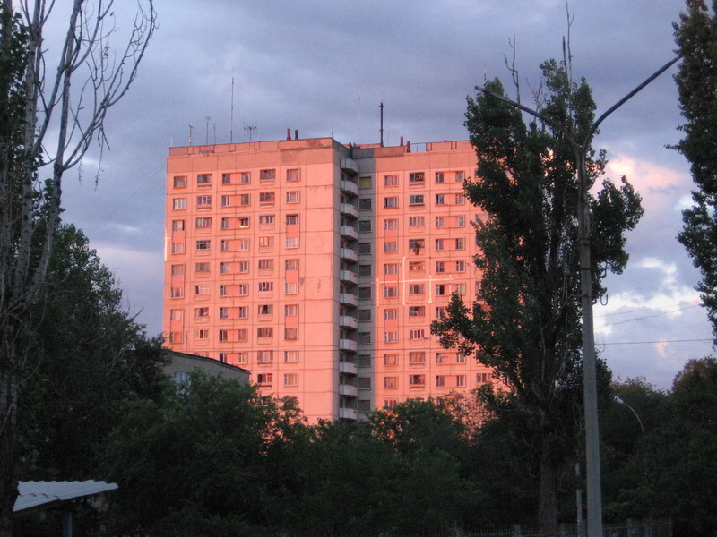
16-этажное здание
ENGLISH 16-storey building
﻿ The first 16-storey building in the city Residential building with 130 apartments. Architect V. Borovikov, engineers V. Manukovsky, V. Sheremetyeva, 1984.
Source: https://bimap.su/description/frunze/301_16et.txt · BIMAP
Фотографии и материалы принадлежат их авторам; лицензия не указана

BISHKEK
No information has been found for this period yet
42.83510, 74.61366

Фотография пока не добавлена
ENGLISH
No information has been found for this period yet.

