ТОГДА / СЕЙЧАС
Дом с магазином «1000 мелочей»
42.87558, 74.62094
Тогда · Frunze
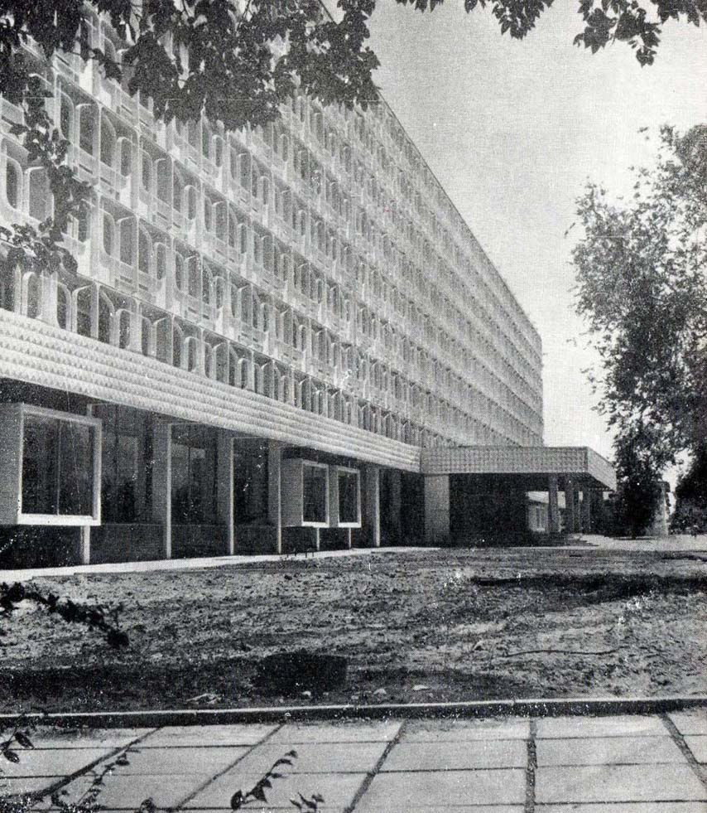
Сейчас · Bishkek


PISHPEK
No information has been found for this period yet
42.87558, 74.62094

Фотография пока не добавлена
ENGLISH
No information has been found for this period yet.

FRUNZE
House with a store “1000 little things”
42.87558, 74.62094
Дом с магазином «1000 мелочей»
ENGLISH House with a store “1000 little things”
﻿ House with a store “1000 little things” Nine-storey residential building with a store “1000 little things”. Architects V. Mechkovsky, S. Nurgaziev, E. Pisarskoy, K. Tokochev, 1977 Reinforced concrete patterned frame panels were used for the first time in the design of the building's loggias.
Source: https://bimap.su/description/frunze/4_1000_melochey.txt · BIMAP
Фотографии и материалы принадлежат их авторам; лицензия не указана

BISHKEK
No information has been found for this period yet
42.87558, 74.62094
Современный вид; дата публикации в 2GIS · Ulan Uli
ENGLISH
No information has been found for this period yet.
Source: https://2gis.kg/bishkek/geo/15763234351118836/tab/photos · 2GIS
Фотография пользователя 2GIS; права принадлежат автору. Изображение показывается по внешней ссылке на 2GIS.

