PISHPEK
No information has been found for this period yet
42.88773, 74.61467

Фотография пока не добавлена
ENGLISH
No information has been found for this period yet.

FRUNZE
School No. 10
42.88773, 74.61467
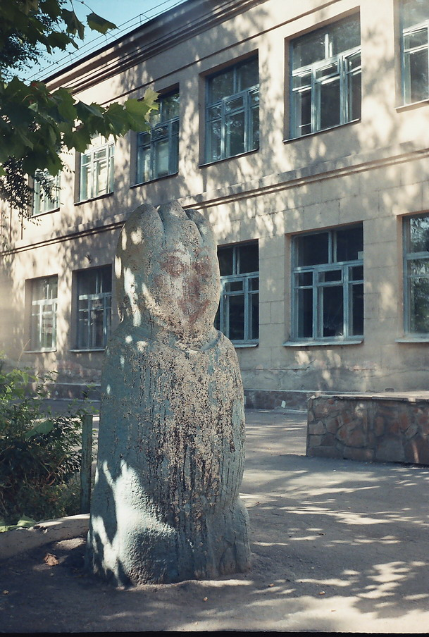
Школа №10 · Владимира Петрова
ENGLISH School No. 10
﻿ School No. 10 By 1940, there were 34 schools in the city's education network. School No. 10 was built in 1938. The school and its immediate surroundings are located on the territory of the Klyuchevskoye settlement. In the middle of the last century, Nikolai Dmitrievich Cherkasov, a remarkable ascetic and researcher of antiquities, worked as a history teacher at this school. Together with his students, he collected a rich archaeological collecti
Source: https://bimap.su/description/frunze/192_Shkola10.txt · BIMAP
Фотографии и материалы принадлежат их авторам; лицензия не указана

BISHKEK
No information has been found for this period yet
42.88773, 74.61467

Фотография пока не добавлена
ENGLISH
No information has been found for this period yet.

