PISHPEK
No information has been found for this period yet
42.82909, 74.60417

Фотография пока не добавлена
ENGLISH
No information has been found for this period yet.

FRUNZE
10th microdistrict
42.82909, 74.60417
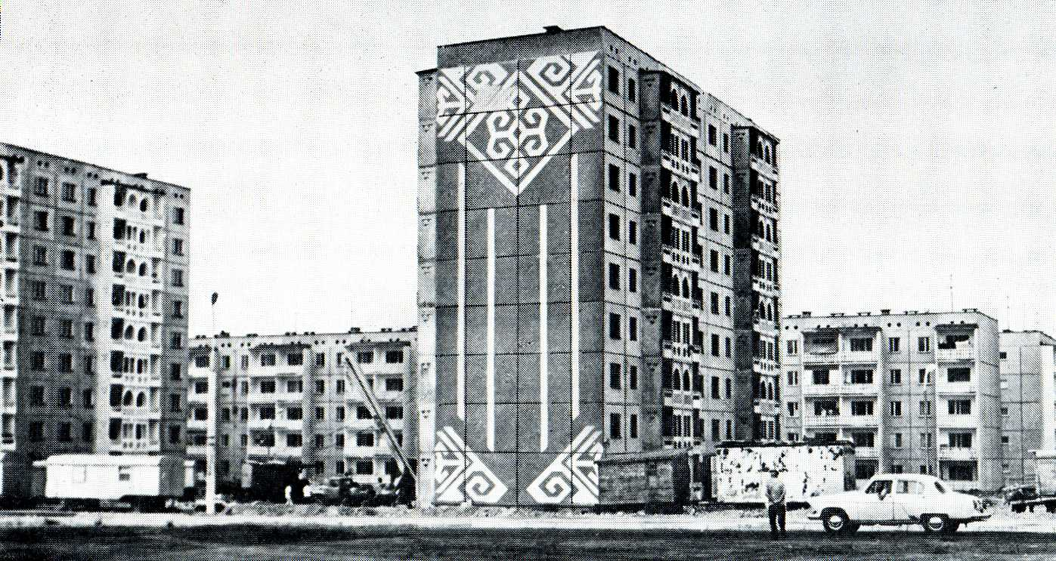
10-й микрорайон
ENGLISH 10th microdistrict
﻿ Southern Gate, 10th microdistrict Architectural ensemble at the entrance to the city along Sovetskaya Street. The western side is completed by the 10th microdistrict. It was built in 1979 with nine-story frame-panel houses of the 106 series.
Source: https://bimap.su/description/frunze/250_Ugvorota.txt · BIMAP
Фотографии и материалы принадлежат их авторам; лицензия не указана

BISHKEK
No information has been found for this period yet
42.82909, 74.60417

Фотография пока не добавлена
ENGLISH
No information has been found for this period yet.

