PISHPEK
No information has been found for this period yet
42.89367, 74.51644

Фотография пока не добавлена
ENGLISH
No information has been found for this period yet.

FRUNZE
Frunze-1
42.89367, 74.51644
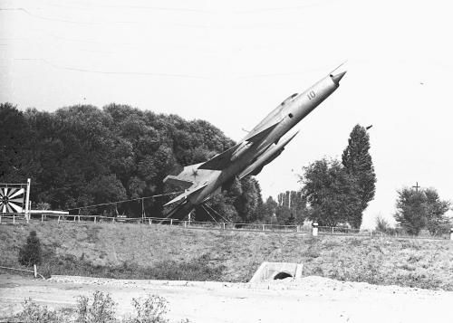
Фрунзе-1
ENGLISH Frunze-1
﻿ Frunze-1 Pilots of the Frunze Military Aviation Pilot School (FVAUL) were trained here, including cosmonaut No. 3 Andriyan Nikolaev, who graduated from the school in 1954. In 1956, the school received the status of a training aviation regiment of the USSR Central Courses for the training and improvement of aviation personnel. Pilots from Africa, Asia, and Latin America were trained here. Among its graduates are the President of Egypt Mohammed H
Source: https://bimap.su/description/frunze/401_Frunze1.txt · BIMAP
Фотографии и материалы принадлежат их авторам; лицензия не указана

BISHKEK
No information has been found for this period yet
42.89367, 74.51644

Фотография пока не добавлена
ENGLISH
No information has been found for this period yet.

