ТОГДА / СЕЙЧАС
Тэц-1
42.87335, 74.65484
Тогда · Frunze
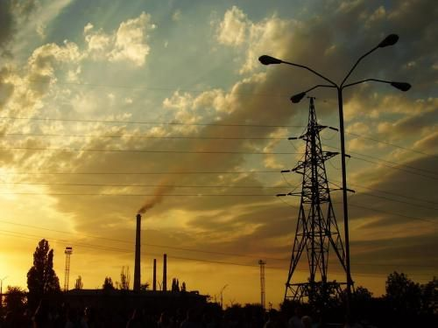
Сейчас · Bishkek


PISHPEK
No information has been found for this period yet
42.87335, 74.65484

Фотография пока не добавлена
ENGLISH
No information has been found for this period yet.

FRUNZE
CHPP-1
42.87335, 74.65484
Тэц-1
ENGLISH CHPP-1
﻿ CHPP-1 CHPP-1. The first turbine unit was put into operation in 1961. Generates electricity and supplies heat to residential areas of the city.
Source: https://bimap.su/description/frunze/396_Tez1.txt · BIMAP
Фотографии и материалы принадлежат их авторам; лицензия не указана

BISHKEK
No information has been found for this period yet
42.87335, 74.65484
Фотография пока не добавлена
ENGLISH
No information has been found for this period yet.

